Kankara, Sudharshan Reddy

**Team D** **–** Phoenix

**Client:** Dr. Michael Oudshoorn

**Project -** Slack/Hipchat collaboration tool

**Role –** Requirements Management

**ITERATION PLAN:**

My role in this project is requirements management. I am responsible for gathering requirements for the project, maintaining and updating them as per client and project. Also, I need to make sure that these requirements are met. I worked for about 38 hours last week in understanding the working of chatting applications, gathering requirements and understanding the project that we need to complete. We have completed 12% of the project. We are on track in obtaining the requirements.

**Project Requirements:**

Requirements document - Have completed about 45% of the requirements document and on track in completing about 70% of the requirements for our project. This is highly critical as we need to get this completed by the end of GDP 1.

**What I accomplished last week:**

I have researched on the working of different chatting applications to find out the possibilities for our project. After this research, I have come up with some requirements that are feasible for our project and have also documented those requirements. I have created use case for the chatting application.

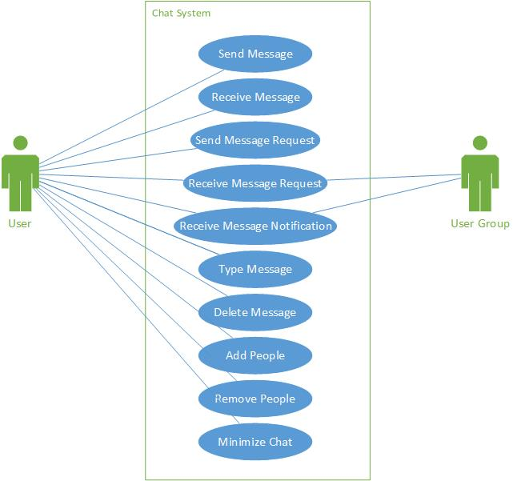

**What I will be accomplishing this week:**

I will work on requirements document and get it completed as detailed as I can. I will also work on cost/time effort estimation along with vineeth and get it completed. I will research on different types of databases that might be helpful for our project. By the end of next I will have completed requirements document, cost/time effort estimation document and have a good enough idea on different databases that will help us in completing our project.

**Unresolved issues or blockers:**

There are no unresolved issues or blockers at this time of the project.

**Riskiest component under development:**

I think that gathering the requirements is the riskiest component in the entire project because this is what we will be working on throughout our project.

**Active efforts that are most critical for client acceptance or GDP completion:**

The most critical component for client acceptance or GDP completion is understanding the client requirements and completing them on time.

**Last week’s submission:**

Kankara, Sudharshan Reddy

**Team D** **–** Phoenix

**Client:** Dr. Michael Oudshoorn

**Project -** Slack/Hipchat collaboration tool

**Role –** Requirements Management

**ITERATION PLAN:**

My role in this project is requirements management. I am responsible for gathering requirements for the project, maintaining and updating them as per client and project. Also, I need to make sure that these requirements are met. I worked for about 12 hours last week in looking at different tools like slack and hipchat to understand their functionality and gathering requirements and understanding the project that we need to complete. We have completed 5% of the project. We are on track in obtaining the requirements.

**What I accomplished last week:**

I met with my team and participated in the meetings and discussed about different possibilities for our project. I have researched about different functionalities in slack and hipchat and came up with some initial requirements.

**What I will be accomplishing this week:**

This week, we need to research about different tools and technologies that we think are useful in completing our project. My role this week is to collect information about different tools and technologies that I think are useful for our project.

**Unresolved issues or blockers:**

There are no unresolved issues or blockers at this time of the project.

**Riskiest component under development:**

I think that gathering the requirements is the riskiest component in the entire project because this is what we will be working on throughout our project.

**Active efforts that are most critical for client acceptance or GDP completion:**

The most critical component for client acceptance or GDP completion is understanding the client requirements and completing them on time.